**Supporting Files**

**Tables**

Table S1: Template search by different servers

Table S2: Homology search from Swiss Model server

Table S3: Ranking of CRIP1a in complex with CB1 receptor C terminus peptide

Table S4: Interactions between CRIP1a and CB1 receptor C terminus peptide

**Figures**

## Figure S1: The Ramachandran plot for best scoring CRIP1b model.

Figure S2: CRIP1a model (A) and its superposition with CRIP1b model (B)

Figure S3: Docked poses of CB1 receptor C terminus peptide on CRIP1a model

Figure S4: CRIP1a docked with CB1 receptor C terminus peptide

**Table S1: Template search by different servers**

Since Blast was not able to search suitable CRIP1b homolog, more sensitive methods were applied. Most of the templates showed less identity with CRIP1b, with very little query coverage.

|  |  |  |  |  |  |
| --- | --- | --- | --- | --- | --- |
| **A. PDBBLAST** | | | **B. HHBLITS** | | |
|  | **score** | **identity** |  | **score** | **identity** |
| 3fcg A | 0.296 | 33% | [2ciw](http://www.rcsb.org/pdb/cgi/explore.cgi?structureId=2CIW) A | 44.3 | 34% |
| 2vl6 A | 1.19 | 43% | [2l74](http://www.rcsb.org/pdb/cgi/explore.cgi?structureId=2L74) A | 36.8 | 15% |
| 3pqu A | 2.25 | 29% | [1ywu](http://www.rcsb.org/pdb/cgi/explore.cgi?structureId=1YWU) A | 35.5 | 15% |
| 1x13 A | 3.33 | 29% | [1pyl](http://www.rcsb.org/pdb/cgi/explore.cgi?structureId=1PYL) A | 25 | 30% |
| 3nx6 A | 6.59 | 34% | [2rde](http://www.rcsb.org/pdb/cgi/explore.cgi?structureId=2RDE) A | 19.2 | 20% |
|  | | | [1fjk](http://www.rcsb.org/pdb/cgi/explore.cgi?structureId=1FJK) A | 12.3 | 27% |
| **C. CSBLAST** | | | [4kyt](http://www.rcsb.org/pdb/cgi/explore.cgi?structureId=4KYT) B | 12.2 | 27% |
|  | **score** | **identity** | [2kz0](http://www.rcsb.org/pdb/cgi/explore.cgi?structureId=2KZ0) A | 11.8 | 9% |
| [3fcg](http://www.rcsb.org/pdb/cgi/explore.cgi?structureId=3FCG) A | 0.5 | 33% | [2mcq](http://www.rcsb.org/pdb/cgi/explore.cgi?structureId=2MCQ) A | 11.8 | 12% |
| [3nx6](http://www.rcsb.org/pdb/cgi/explore.cgi?structureId=3NX6) A | 1.5 | 33% | [3bfm](http://www.rcsb.org/pdb/cgi/explore.cgi?structureId=3BFM) A | 11.4 | 16% |
| [3lvf](http://www.rcsb.org/pdb/cgi/explore.cgi?structureId=3LVF) O | 2.2 | 25% |  | | |
| [4k4k](http://www.rcsb.org/pdb/cgi/explore.cgi?structureId=4K4K) A | 2.8 | 25% | **D. HHSEARCH** | | |
| [4ifd](http://www.rcsb.org/pdb/cgi/explore.cgi?structureId=4IFD) A | 3 | 35% |  | **score** | **identity** |
| [2j63](http://www.rcsb.org/pdb/cgi/explore.cgi?structureId=2J63) A | 3.1 | 34% | [1yhp](http://www.rcsb.org/pdb/cgi/explore.cgi?structureId=1YHP) A | 26.2 | 15% |
| [2drh](http://www.rcsb.org/pdb/cgi/explore.cgi?structureId=2DRH) A | 3.2 | 30% | [3hrs](http://www.rcsb.org/pdb/cgi/explore.cgi?structureId=3HRS) A | 10.6 | 20% |
| [3pie](http://www.rcsb.org/pdb/cgi/explore.cgi?structureId=3PIE) A | 3.5 | 28% | [1cyg](http://www.rcsb.org/pdb/cgi/explore.cgi?structureId=1CYG) A | 5.38 | 17% |
| [1sif](http://www.rcsb.org/pdb/cgi/explore.cgi?structureId=1SIF) A | 3.9 | 29% | [3qde](http://www.rcsb.org/pdb/cgi/explore.cgi?structureId=3QDE) A | 5.3 | 29% |
| [3ego](http://www.rcsb.org/pdb/cgi/explore.cgi?structureId=3EGO) A | 3.9 | 43% | [1vjj](http://www.rcsb.org/pdb/cgi/explore.cgi?structureId=1VJJ) A | 5.09 | 11% |
|  | | | [2q3z](http://www.rcsb.org/pdb/cgi/explore.cgi?structureId=2Q3Z) A | 4.83 | 13% |
| **E. COMA** | | | [3qtd](http://www.rcsb.org/pdb/cgi/explore.cgi?structureId=3QTD) A | 4.65 | 18% |
|  | **score** | **identity** | [1vpb](http://www.rcsb.org/pdb/cgi/explore.cgi?structureId=1VPB) A | 4.13 | 15% |
| [3lzl](http://www.rcsb.org/pdb/cgi/explore.cgi?structureId=3LZL) A | 0.61 | 29% | [4asl](http://www.rcsb.org/pdb/cgi/explore.cgi?structureId=4ASL) A | 4.06 | 18% |
|  | | | [3t2l](http://www.rcsb.org/pdb/cgi/explore.cgi?structureId=3T2L) A | 3.67 | 21% |
| **F. FFAS** | | |  | | |
|  | **score** | **identity** | **G. PHYRE** | | |
| [3mep](http://www.rcsb.org/pdb/cgi/explore.cgi?structureId=3MEP) A | -7.17 | 12% |  | **score** | **identity** |
| [2k0r](http://www.rcsb.org/pdb/cgi/explore.cgi?structureId=2K0R) A | -6.96 | 15% | [2ha1](http://www.rcsb.org/pdb/cgi/explore.cgi?structureId=2HA1) A | 15 | 10% |
| [2cd0](http://www.rcsb.org/pdb/cgi/explore.cgi?structureId=2CD0) A | -6.53 | 14% | [1qg3](http://www.rcsb.org/pdb/cgi/explore.cgi?structureId=1QG3) B | 20 | 18% |
| [3IMZ](http://www.rcsb.org/pdb/cgi/explore.cgi?structureId=3IMZ) E | -6.46 | 15% | [1hr0](http://www.rcsb.org/pdb/cgi/explore.cgi?structureId=1HR0) W | 22 | 26% |
| [2w0k](http://www.rcsb.org/pdb/cgi/explore.cgi?structureId=2W0K) A | -6.42 | 15% | [1hs6](http://www.rcsb.org/pdb/cgi/explore.cgi?structureId=1HS6) A | 23 | 10% |
| [1cd0](http://www.rcsb.org/pdb/cgi/explore.cgi?structureId=1CD0) A | -6.41 | 13% | [2gcx](http://www.rcsb.org/pdb/cgi/explore.cgi?structureId=2GCX) A | 26 | 23% |
| [2w68](http://www.rcsb.org/pdb/cgi/explore.cgi?structureId=2W68) A | -6.3 | 13% | [1ah9](http://www.rcsb.org/pdb/cgi/explore.cgi?structureId=1AH9) A | 28 | 35% |
| [3i6v](http://www.rcsb.org/pdb/cgi/explore.cgi?structureId=3I6V) A | -6.24 | 15% | [2h3j](http://www.rcsb.org/pdb/cgi/explore.cgi?structureId=2H3J) A | 28 | 23% |
| [1fch](http://www.rcsb.org/pdb/cgi/explore.cgi?structureId=1FCH) A | -6.19 | 15% | [1ug9](http://www.rcsb.org/pdb/cgi/explore.cgi?structureId=1UG9) A2 | 30 | 20% |
| [3lso](http://www.rcsb.org/pdb/cgi/explore.cgi?structureId=3LSO) A | -6.19 | 17% | [2yx2](http://www.rcsb.org/pdb/cgi/explore.cgi?structureId=2YX2) A | 32 | 18% |

|  |  |  |  |  |  |
| --- | --- | --- | --- | --- | --- |
| **Name** | **Title** | **Identity** | **Method** | **Oligo State** | **Ligands** |
| 1ds6.1.B | RHO GDP-DISSOCIATION INHIBITOR 2 | 27.45 | X-ray, 2.3Å | hetero-oligomer | 1 x GDP, 1 xMG |
| 2n80.1.B | Rho GDP-dissociation inhibitor 1 | 17.65 | NMR | hetero-oligomer | None |
| 1fst.1.A | RHO GDP-DISSOCIATION INHIBITOR 1 | 17.65 | X-ray, 2.7Å | monomer | None |
| 1cc0.1.B | rho GDP dissociation inhibitor alpha | 17.65 | X-ray, 5.0Å | hetero-oligomer | 1 x GDP, 1 xMG |
| 1rho.1.A | RHO GDP-DISSOCIATION INHIBITOR 1 | 17.65 | X-ray, 2.5Å | monomer | None |
| 1rho.2.A | RHO GDP-DISSOCIATION INHIBITOR 1 | 17.65 | X-ray, 2.5Å | monomer | None |
| 1hh4.1.B | RHO GDP-DISSOCIATION INHIBITOR 1 | 17.65 | X-ray, 2.7Å | hetero-oligomer | 1 x GDP, 1 xGER, 1 x MG |
| 1ajw.1.A | RHOGDI | 17.65 | NMR | monomer | None |
| 1gdf.1.A | RHOGDI | 17.65 | NMR | monomer | None |
| 3nrp.1.A | Periplasmic protein-probably involved in high-affinity Fe2+ transport | 27.08 | X-ray, 1.6Å | homo-dimer | None |

**Table S2: Homology search from Swiss Model server**

Chain B of 1ds6 pdb structure, the RHO GDP-DISSOCIATION INHIBITOR 2 was chosen as template for CRIP1b modeling as it provides significant identity with maximum query coverage.

**Table S3: Ranking of CRIP1a in complex with CB1 receptor C terminus peptide**

The global energy represents total binding energy of complex which is contributed by attractive and repulsive Van der Wals forces (VdW), atomic contact energy(ACE) and hydrogen bond energy(HB).

|  |  |  |  |  |  |  |
| --- | --- | --- | --- | --- | --- | --- |
| Rank | Solution Number | Global Energy | Attractive VdW | Repulsive VdW | ACE | HB |
| 1 | 5 | -58.67 | -30.21 | 6.87 | -8.84 | -4.51 |
| 2 | 4 | -54.86 | -28.19 | 5.56 | -6.88 | -4.31 |
| 3 | 8 | -43.41 | -20.14 | 5.76 | -10.05 | -2.82 |
| 4 | 3 | -40.20 | -25.22 | 3.18 | -6.39 | -4.82 |
| 5 | 10 | -37.16 | -27.53 | 13.18 | -10.89 | -4.40 |
| 6 | 1 | -34.65 | -21.94 | 4.09 | -6.53 | -1.56 |
| 7 | 2 | -34.65 | -21.94 | 4.09 | -6.53 | -1.56 |
| 8 | 6 | -30.99 | -22.34 | 5.72 | -1.93 | -4.82 |
| 9 | 7 | -30.99 | -22.34 | 5.72 | -1.93 | -4.82 |
| 10 | 14 | -26.58 | -14.90 | 2.61 | -3.41 | -0.70 |
| 11 | 11 | -24.37 | -25.07 | 5.59 | -3.97 | 0.00 |
| 12 | 9 | -21.18 | -17.37 | 6.48 | -4.43 | -3.17 |
| 13 | 12 | -16.42 | -24.26 | 6.43 | -4.82 | -1.44 |
| 14 | 13 | -9.69 | -13.17 | 1.52 | -2.15 | -2.26 |

**Table S4(A-D): Interactions between CRIP1a and CB1 receptor C terminus peptide.**

The Chain A represents CRIP1a while chain B represents CB1-R peptide.

Dd-a (Distance Between Donor and Acceptor); Dh-a( Distance Between Hydrogen and Acceptor), A(d-H-N)( Angle Between Donor-H-N), A(a-O=C)(Angle Between Acceptor-O=C), MO(Multiple Occupancy),Note the values that are undefined are written as “–“.

|  |  |  |  |  |  |  |  |  |  |  |  |  |  |  |  |  |  |  |  |  |  |  |  |  |  |
| --- | --- | --- | --- | --- | --- | --- | --- | --- | --- | --- | --- | --- | --- | --- | --- | --- | --- | --- | --- | --- | --- | --- | --- | --- | --- |
| 1. **Binding pocket residues of CRIP1a within 4 Angstroms of CB1 R -peptide** | | | | | | | | | | | | | | | | | | | | | | | | | |
| **Position** | | 61 | | 63 | | 80 | | | | 81 | | | 82 | | 83 | | | 126 | | | 127 | | | 130 | |
| **Residue** | | ASN | | SER | | GLY | | | | ASP | | | ARG | | VAL | | | TYR | | | ASN | | | LYS | |
|  | | | | | | | | | | | | | | | | | | | | | | | | | |
| 1. **Hydrophobic Interactions within 5 Angstroms** | | | | | | | | | | | | | | | | | | | | | | | | | |
| **Position** | | **Residue** | | | | | **Chain** | | | | **Position** | | | | | **Residue** | | | | | | **Chain** | | | |
| 83 | | VAL | | | | | A | | | | 469 | | | | | ALA | | | | | | B | | | |
| 126 | | TYR | | | | | A | | | | 471 | | | | | ALA | | | | | | B | | | |
| 128 | | TYR | | | | | A | | | | 472 | | | | | LEU | | | | | | B | | | |
|  | | | | | | | | | | | | | | | | | | | | | | | | | |
| 1. **Protein-Protein Main Chain-Main Chain Hydrogen Bonds** | | | | | | | | | | | | | | | | | | | | | | | | | |
| **Donor** | | | | | | | | **Acceptor** | | | | | | | | | **Parameters** | | | | | | | | |
| **POS** | **CHAIN** | | **RES** | | **ATOM** | | | **POS** | **CHAIN** | | | **RES** | | **ATOM** | | | **MO** | | **Dd-a** | **Dh-a** | | | **A(d-H-N)** | | **A(a-O=C)** |
| 128 | A | | TYR | | N | | | 471 | B | | | ALA | | O | | | - | | 2.74 | 3.17 | | | 56.03 | | 149.68 |
| 464 | B | | SER | | N | | | 81 | A | | | ASP | | O | | | - | | 2.54 | -- | | | -- | | -- |
| 465 | B | | THR | | N | | | 81 | A | | | ASP | | O | | | - | | 3.20 | 3.25 | | | 78.22 | | 128.16 |
| 466 | B | | ASP | | N | | | 81 | A | | | ASP | | O | | | - | | 3.23 | 2.88 | | | 101.70 | | 120.39 |
|  | | | | | | | | | | | | | | | | | | | | | | | | | |
| 1. **Protein-Protein Main Chain-Side Chain Hydrogen Bond** | | | | | | | | | | | | | | | | | | | | | | | | | |
| **POS** | **CHAIN** | | **RES** | | **ATOM** | | | **POS** | **CHAIN** | | | **RES** | | **ATOM** | | | **MO** | | **Dd-a** | **Dh-a** | | | **A(d-H-N)** | | **A(a-O=C)** |
| 63 | A | | SER | | OG | | | 470 | B | | | GLU | | O | | | - | | 3.15 | -- | | | -- | | 107.28 |
| 63 | A | | SER | | OG | | | 472 | B | | | LEU | | O | | | - | | 2.58 | -- | | | -- | | 82.83 |
| 63 | A | | SER | | OG | | | 472 | B | | | LEU | | OXT | | | - | | 3.21 | -- | | | -- | | 56.29 |
| 464 | B | | SER | | OG | | | 83 | A | | | VAL | | O | | | - | | 3.16 | -- | | | -- | | 143.34 |
| 467 | B | | THR | | N | | | 81 | A | | | ASP | | OD2 | | | - | | 2.88 | 2.85 | | | 81.17 | | 110.66 |
| 472 | B | | LEU | | N | | | 63 | A | | | SER | | OG | | | - | | 2.99 | 2.78 | | | 92.07 | | -- |
|  | | | | | | | | | | | | | | | | | | | | | | | | | |
| 1. **Protein-Protein Side Chain-Side Chain Hydrogen Bonds** | | | | | | | | | | | | | | | | | | | | | | | | | |
| **POS** | **CHAIN** | | **RES** | | **ATOM** | | | **POS** | **CHAIN** | | | **RES** | | **ATOM** | | | **MO** | | **Dd-a** | **Dh-a** | | | **A(d-H-N)** | | **A(a-O=C)** |
| 126 | A | | TYR | | OH | | | 470 | B | | | GLU | | OE1 | | | - | | 2.67 | -- | | | -- | | -- |
| 467 | B | | THR | | OG1 | | | 81 | A | | | ASP | | OD2 | | | - | | 2.18 | -- | | | -- | | -- |
| 470 | B | | GLU | | OE2 | | | 81 | A | | | ASP | | OD1 | | | 1 | | 3.23 | 2.90 | | | 98.39 | | -- |
| 470 | B | | GLU | | OE2 | | | 81 | A | | | ASP | | OD1 | | | 2 | | 3.23 | 3.46 | | | 68.77 | | -- |

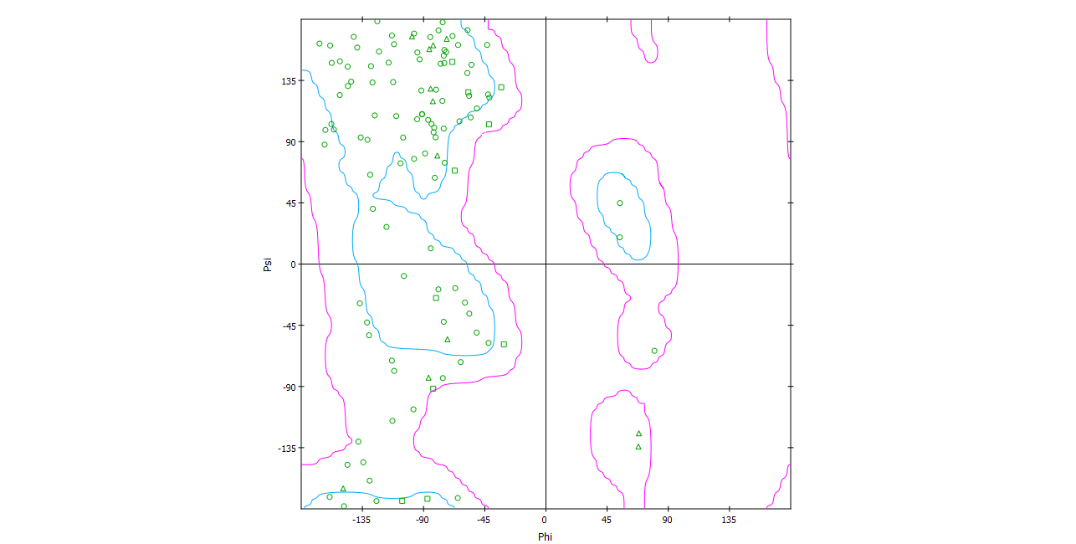

## 

## Figure S1: The Ramachandran plot for best scoring CRIP1b model.

## The plot generated by Discovery studio, shows all the residues in favorable region, indicating the model to be valid.

## 

A B

**Figure S2: CRIP1a model (A) and its superposition with CRIP1b model (B)**

The CRIP1a model was also predicted in the same manner as CRIP1b using Rho-GDI2 as template. The CRIP1a (red) superposed with CRIP1b (blue), show similar folds.

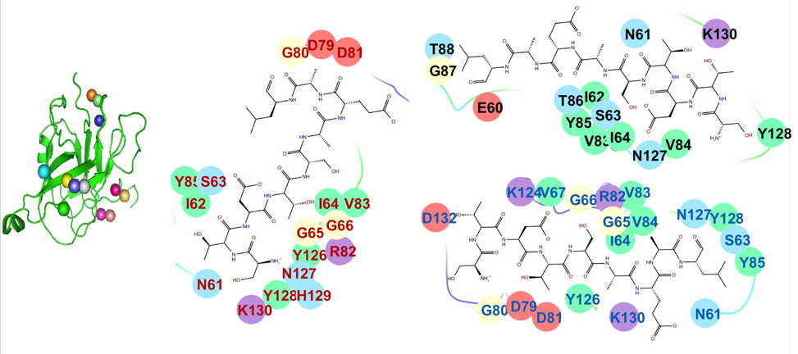

**Figure S3: Docked poses of CB1 receptor C terminus peptide on CRIP1a model**

Docking studies yielded various docked complexes with peptide on distinct positions. All the poses were refined and scored. On the left side of figure, the colored spheres show the positions of peptide on CRIP1a in different poses. While on the right side, binding pockets of top scoring poses from three different clusters are written with differently colored residue fonts. Also, the chemical properties of residues are represented by oval background of different colors i.e., negative charged by pink, positive charged by violet, hydrophobic by green, polar by light blue and glycine by cream.

BP_CRIP1a_HiRes.tiff

**Figure S4: CRIP1a docked with CB1 receptor C terminus peptide**

The binding pocket of best scoring docked pose of CRIP1a in complex with CB1R peptide showing the hydrogen bonds (blue dashed lines).